# MGT 388 Finance and Law for Engineers

# Finance Lecture 6 Notes

# Cost-Volume-Profit (CVP) Analysis 成本数量利润分析

CVP analysis is a fundamental technique to examine the relationship between changes in activity (where activity means output volume or number of units) and changes in total sales revenue, costs, and profit.

CVP analysis is based on the basic equation that relates profit, sales revenue, and costs.

Looking at the cost-volume-profit analysis for breakeven planning, there are two methods for determining Break-even point (BEP) and target operating profit: the equation method and the contribution margin method.

We can represent BEP using two different graphs: the CVP graph and the profit-volume graph.

In the CVP graph, we represent the output volume on the horizontal axis, and both cost and revenue on the vertical axis.

The BEP is the point where the half-line of total revenue crosses the half-line of total cost.

You can see that the half-line of total revenue starts from zero and its angular coefficient is the unit selling price. The half-line of total cost starts from the amount of fixed cost on the vertical axis (60,000$) and its angular coefficient is the unit variable price. That is why the slope of the total revenue line is greater than the slope of the total cost line. It has a greater angular coefficient because the unit selling price is higher than the unit variable cost.

The half-line of fixed cost is parallel to the horizontal axis because 60,000 $ is a constant, a fixed value that does not depend on the output volume.

At the BEP the quantity is 1,500 units on the horizontal axis and the revenue is 112,500 $ on the vertical axis.

The light grey area to the right of the BEP, is the area of profit because total revenue is higher than total cost, so the half-line of total revenue is above the half-line of total cost.

The dark grey area to the left of the BEP, is the area of loss because total revenue is lower than total cost, so the half-line of total revenue is below the half-line of total cost.

In the profit-volume graph, we represent the output volume as usual on the horizontal axis and the profit on the vertical axis. Therefore, the BEP lies on the horizontal axis because it corresponds to zero profit.

The half-line of profit starts from minus 60,000 $ because when the output volume is zero, also the revenue is zero, so the fixed cost is entirely translated into a loss.

Even in this case the area of profit in coloured in light grey and the area of loss in dark grey.

CVP 分析是检查活动变化（活动指产出量或单位数量）与总销售收入、成本和利润变化之间关系的基本技术。

CVP 分析基于关联利润、销售收入和成本的基本方程。

从盈亏平衡计划的本量利分析来看，确定盈亏平衡点（BEP）和目标营业利润的方法有两种：方程法和边际贡献法。

我们可以使用两种不同的图表来表示 BEP：CVP 图和利润量图。

在 CVP 图中，横轴表示产出量，纵轴表示成本和收入。

BEP 是总收入的半线与总成本的半线相交的点。

可以看到，总收入的半线从零开始，其角度系数就是单位售价。 总成本的半线从纵轴上的固定成本金额（60,000美元）开始，其角度系数是单位可变价格。 这就是为什么总收入线的斜率大于总成本线的斜率。 它具有更大的角度系数，因为单位售价高于单位可变成本。

固定成本的半线与横轴平行，因为 60,000 美元是一个常数，一个不依赖于产量的固定值。

在 BEP 中，横轴上的数量为 1,500 单位，纵轴上的收入为 112,500 美元。

BEP 右侧的浅灰色区域是利润区域，因为总收入高于总成本，因此总收入的半线高于总成本的半线。

BEP 左侧的深灰色区域是损失区域，因为总收入低于总成本，因此总收入的半线低于总成本的半线。

在利润-数量图中，我们像往常一样在横轴上表示产出量，在纵轴上表示利润。 因此，BEP 位于横轴上，因为它对应于零利润。

利润的半线从负60,000美元开始，因为当产量为零时，收入也为零，因此固定成本完全转化为亏损。

即使在这种情况下，盈利区域也显示为浅灰色，亏损区域显示为深灰色。

Budgeting and budgets

A budget is an organisation’s operational plan for a specified period (usually for 1 year) and it is expressed in quantitative terms, mainly in financial terms.

Budgeting is the process of preparing a budget. A budget, as the final output of budgeting, is composed of different budget statements.

An annual budget sets targets for the forthcoming period for all aspects of the business. It is often prepared for a budget period of one year, coinciding with the business’s annual report period. The annual budget is usually further split into shorter periods of quarters, months, or even single weeks depending on the information needs of different internal users (e.g., monthly cash budget).

A budget is a plan

A budget should inform staff of where the company is supposed to be *(the destination)*, so the budget objectives to achieve,and how it is going to get there *(the route map)*.

A budget is not a forecast. A budget is a plan for the short term.

What is the difference between a forecast and a plan?

A plan includes the intention to achieve some targets, while forecasts tend to be predictions of the future state of the environment. Obviously, forecasts are very helpful for strategic planning and budgeting. For example, a reputable forecaster has predicted the number of new cars to be purchased in the UK during next year. It will be valuable for a manager in a car manufacturing business to take this forecast into account when setting sales budgets.

# The purposes of budget

Budgets are widely used for planning, controlling, and evaluating outcomes. Budgeting is done by the management of large companies, as well as SMEs, local entities, universities, schools, hospitals, and all other public sector and not for profit organisations. Managers are the actors of budgeting, as they are responsible for setting budget objectives and targets with the support of management accountants.

Budgets have multiple purposes.

The first purpose is planning. Management formulates plans for future to help carry out the actions, so budgets are based on scenario analysis. By focusing on the future, managers may be able to spot potential problems at an early stage, so they can take action in advance and find the best solution. For example, the budgeting process may reveal a potential shortage of production capacity, so managers can deal with this issue well in advance.

Second, budgets can help co-ordinate the various sections of the business, such as different departments, organisational units, management levels, etc…

For example, it is important that the activities of the purchasing department of a manufacturing business are coordinated with the raw materials needs of the production departments, otherwise there could be some expensive production interruptions or alternatively too large and expensive inventories.

Third, communication is another important purpose of budget. Communication of objectives and related targets to all managers and staff.

Fourth, budgets should motivate managers and staff to better performance. Having a stated target, so establishing a required level of achievement, should be motivating and align personal objectives with the objectives of the business.

Moreover, managers need to control activities to ensure that the plan is followed, so budgets should provide a basis for a control system. Where information concerning actual performance for a period is available, it can be compared with planned objectives (budget). To make this comparison easier, actual outcome should be stated in the same terms as the budget. Where actual outcomes are at variance with the budgets, this will be highlighted, so managers can take steps to get things back on track to achieve the budgeted objectives. Other types of comparison are between current performance and past performance, with reference to a year, a quarter, or a month. For example, a comparison between sales in January 2021 and in January 2020. Furthermore, current performance can be compared with performance of another business (typically the main competitors) in the same period.

Lastly, another purpose of budgets is evaluating the performance of managers. According to responsibility accounting, managers are held to be answerable for the performance against budget of the areas and functions for which they are responsible.

To set targets is not an easy task, because where targets are unreasonable demanding or conversely too easy to achieve, so too high or too low, the impact on managers motivation can be negative.

Furthermore, the six functions of budget can conflict with one another, so managers must give priority to some functions and uses. For example, challenging targets can be motivating for managers, but not suitable for control purposes, so managers need to decide what is the most important function in that company.

# Strategic planning and budgeting

Now, before exploring the budgeting process and the different typologies of budgets, we need to understand the importance of strategy in budgeting. So, what is strategy?

Strategy is the path a firm chooses for attaining its mission, its reason to exist and operate.

In other terms, to run a successful business, managers should clearly identify what the future direction of the business should be and develop a strategic plan accordingly.

The ultimate purpose of the business is often set out in a mission statement. This is a broad statement of intent, which tries to capture the essence of the business and is likely to last for quite a long time, perhaps throughout the life of the business.

For example, the mission of Ferrari is “*We build cars, symbols of Italian excellence the world over, and we do so to win on both road and track. Unique creations that fuel the Prancing Horse legend and generate a “World of Dreams and Emotions*”. This is the essence, the DNA of Ferrari.

The formulation of strategy starts from the mission statement and requires on the one hand to analyse the external factors, and on the other hand to assess the internal conditions.

The analysis of external factors, such as economy, politics, technology, regulation, society, environment, competition, etcetera, is needed to identify opportunities, limitations, and threats. The assessment of internal condition, such as finance, management, structure, morale, culture, etcetera, is needed to recognise strengths, weaknesses, and competitive advantages. The technique to make this external and internal analysis is called SWOT Analysis, where SWOT stands for Strengths, Weaknesses, Opportunities, and Threats.

The result of SWOT analysis is to match the opportunities with the strengths and competitive advantages, to identify and evaluate the strategic options, which are the various ways to move from the current position to the desired mission. Then, managers need to select what seems to be the best strategic options and finalise strategic goals and long-term decisions in a strategic plan, typically over a period of three to five years.

Strategic long-term goals translate the mission into specific, often quantifiable, targets. Strategic plan identifies how each goal will be pursued.

The budget is a short-term financial plan for the business, which is prepared within the framework of the strategic plan. Its role is to covert the strategic plan into objectives for the immediate future.

# Master budget

The output of a budgeting process is a master budget or, in other words, a summary of individual budgets, including cash flow forecast, budgeted profit & loss account, and budgeted balance sheet. Now, looking at each individual budget:

* The Budget cash flow statement (or cash budget) shows the budgeted cash inflows and cash outflows.
* The Budget account of profit & loss (or budget income statement) shows the budgeted revenues and expenses.
* The Budget balance sheet (or budget statement of financial position) shows the budgeted state of financial health, expressed by the balance between assets, liabilities, and equity.

# Budgeting process

Master budgets cannot be drawn up until the sub-budgets for revenues and for expenses are drawn up. The starting point for budgets is the sales budget. In a commercial organisation, sales volume is the principal factor that determines the scale of the business’s activities. In a manufacturing organisation, sales volumes and inventory levels are the basis to determine the budgets for production, direct labour, and production overheads.

The finished inventories requirement tends to be set by the level of sales, but it would also depend on the policy of the business regarding the level of inventories.

The requirement for finished inventories will determine the required production levels. The demands of manufacturing, in conjunction with the business’s policy on raw materials inventories, will determine the raw materials inventories budget and the purchases budget.

The latter, in conjunction with the policy of the business concerning the credit period from suppliers, will determine the trade payables budget. On the other hand, the sales budget, in conjunction with the policy concerning the settlement period granted to credit customers, will determine the trade receivables budget.

Both the trade payables budget and the trade receivables budget will contribute to cash budget. Cash will also be affected by overheads, direct labour costs and capital expenditure.

Moreover, cash will be affected by any injection of new finance (in terms of cash inflows) and the redemption of existing finance (in terms of cash outflows).

Finally, budgets are also required for research and development, administration expenses, capital expenditure and marketing and advertising.

Budgeting is not a simple process and involves four main steps: constructing the budget, co-ordinating the budget, implementing the budget, and controlling and reviewing the budget.

The first step is constructing the budget. Budget is usually referred to one year and integrates all activities that can be expressed as a quantity. It summarises all targets for a year, starting from revenues and costs and considering the limiting factors, such as the sales demand of products and services or the productive capacity or both.

The second step of budgeting process is co-ordinating the budget, so bringing all mini budgets together, making the needed adjustments and creating master budget.

For example, the budgeted income statement needs to be adjusted after drafting the cash budget and the budgeted balance sheet to introduce a more precise amount of financial costs.

The third step is implementing the budget, which means to commit resources. For example, to order new equipment, contract with suppliers, recruit new staff, etcetera. Budgets can also provide a system of authorisation to spend. Some activities, such as research and development, are usually allocated a fixed amount of funds at the discretion of senior management.

Finally, the fourth step is controlling and reviewing the budget, to answer the questions: How are we doing? Are we on the right route to getting our destination?

Control should be done at regular intervals, depending on situation and needs, and it should be based on the comparison between budgeted figures and actual figures, so on variance analysis using standard costing. Management by exception is a system of control, based on a comparison of planned and actual performance. This system allows managers to save time, focusing on areas of poor performance rather than dealing with areas where performance is satisfactory.

Budgets are constructed both for cash items and for non-cash items. For example, for the number of units in stock. Non-financial targets and measures can also be reported in budgets alongside the financial ones, as they have become of critical importance to businesses in the current competitive environment.

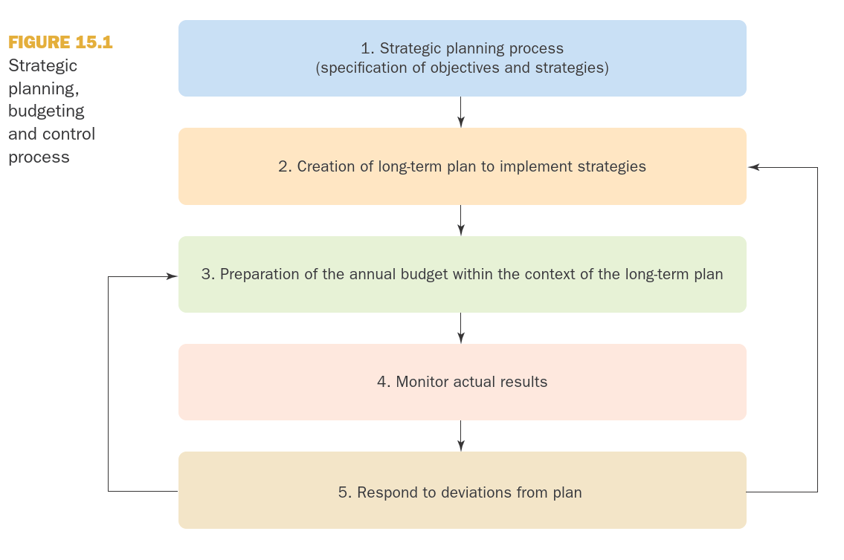

Source: Drury, C.M., 2021. *Management and cost accounting*, 11th Edition. Springer.